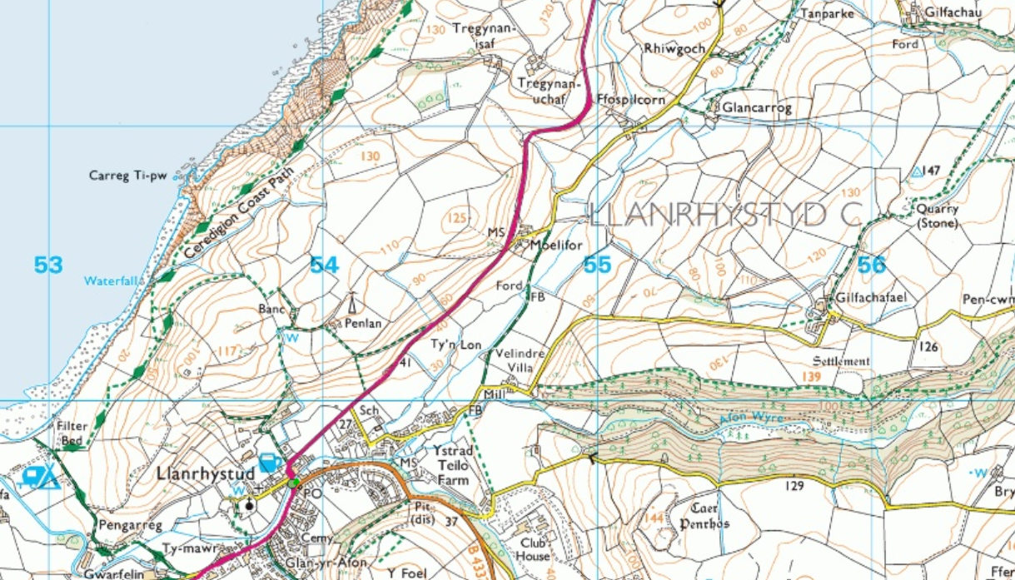
Llwybr ar gau
Path closed

Trywydd dros dro
Temporary route

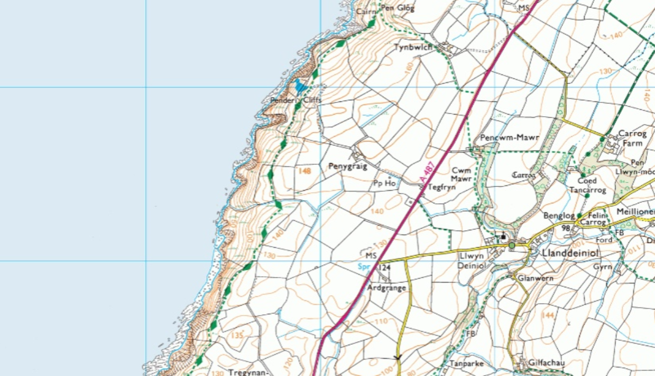
Llwybr ar gau
Path closed

Trywydd dros dro
Temporary route

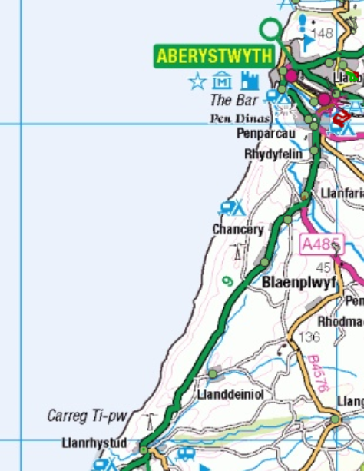
Ardal wedi ei effeithio
Affected area

